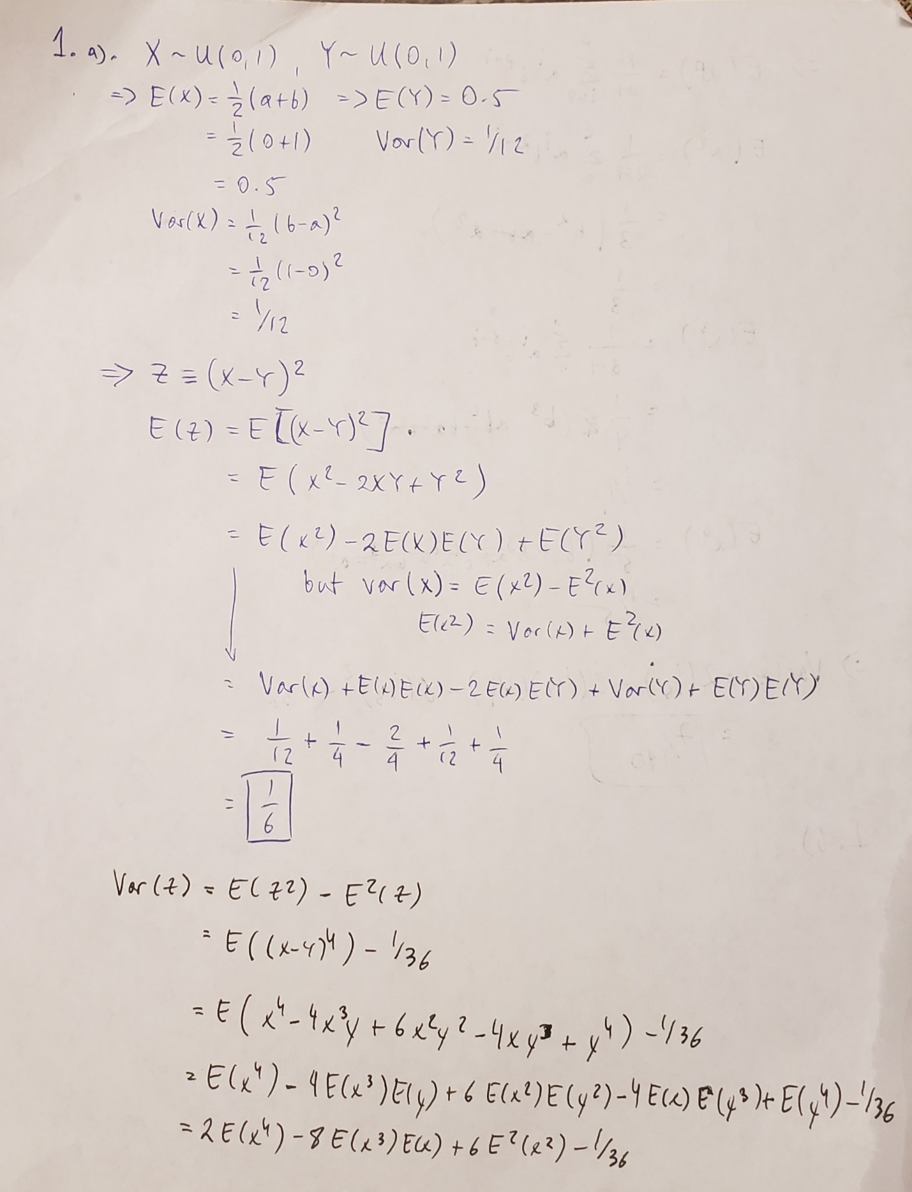

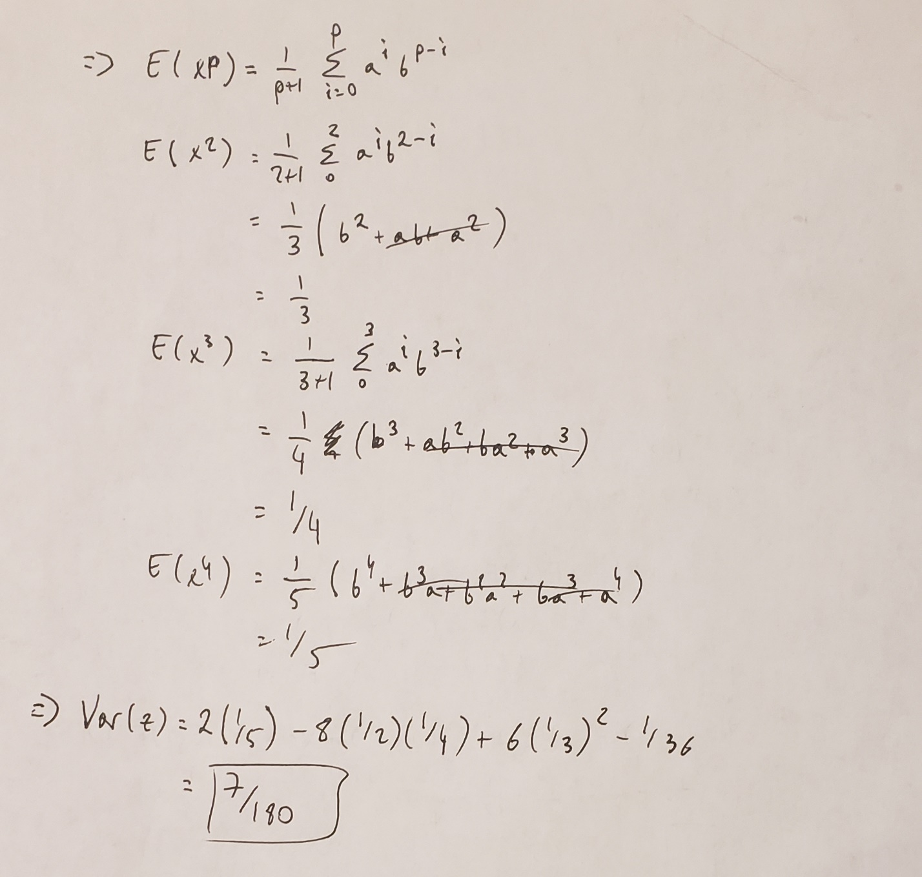

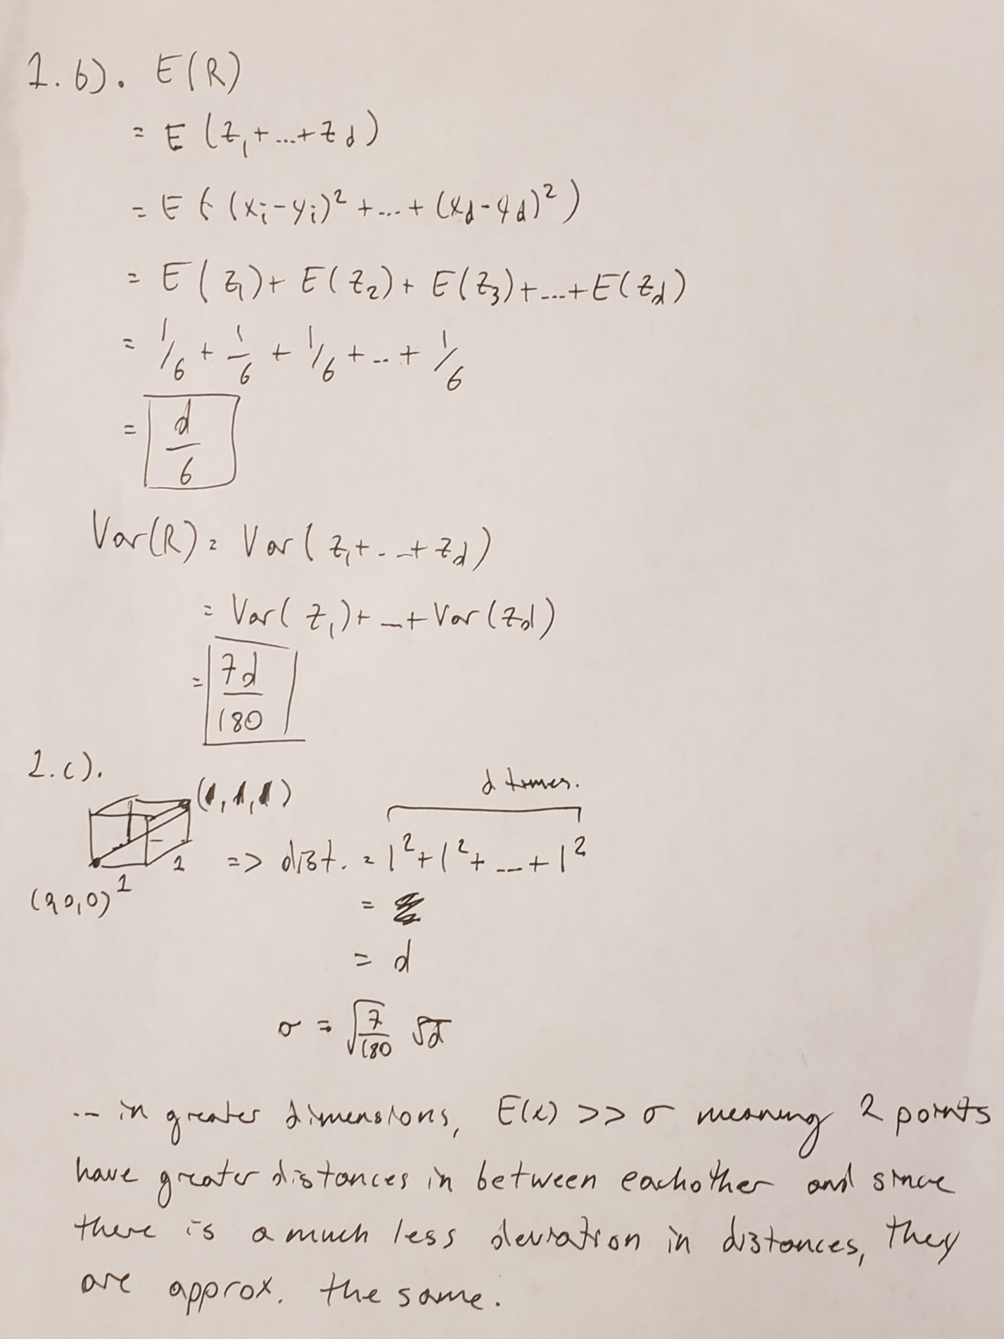

2. b)

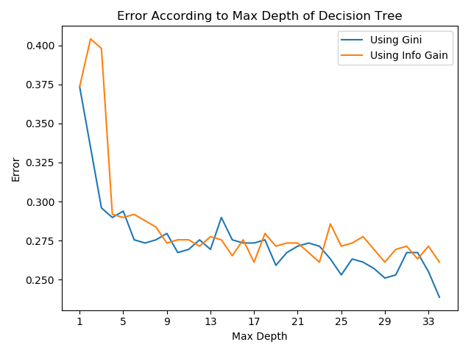

Here are the accuracies for a max depth of 1 – 33 for each split criterion. I chose to use a Gini hyperparameter and max depth of 6 for part c).

Printout:

For depth 0, gini error = 0.34285714285714286, ig error = 0.34285714285714286

For depth 1, gini error = 0.33061224489795915, ig error = 0.34285714285714286

For depth 2, gini error = 0.30204081632653057, ig error = 0.30204081632653057

For depth 3, gini error = 0.30204081632653057, ig error = 0.30204081632653057

For depth 4, gini error = 0.310204081632653, ig error = 0.30204081632653057

For depth 5, gini error = 0.29387755102040813, ig error = 0.310204081632653

For depth 6, gini error = 0.28979591836734697, ig error = 0.28775510204081634

For depth 7, gini error = 0.2918367346938775, ig error = 0.28367346938775506

For depth 8, gini error = 0.28163265306122454, ig error = 0.28367346938775506

For depth 9, gini error = 0.27755102040816326, ig error = 0.28775510204081634

For depth 10, gini error = 0.2755102040816326, ig error = 0.28163265306122454

For depth 11, gini error = 0.27142857142857146, ig error = 0.2795918367346939

For depth 12, gini error = 0.273469387755102, ig error = 0.2857142857142857

For depth 13, gini error = 0.27755102040816326, ig error = 0.28163265306122454

For depth 14, gini error = 0.2795918367346939, ig error = 0.28367346938775506

For depth 15, gini error = 0.273469387755102, ig error = 0.28163265306122454

For depth 16, gini error = 0.2755102040816326, ig error = 0.2693877551020408

For depth 17, gini error = 0.2693877551020408, ig error = 0.2979591836734694

For depth 18, gini error = 0.27142857142857146, ig error = 0.27755102040816326

For depth 19, gini error = 0.2693877551020408, ig error = 0.2755102040816326

For depth 20, gini error = 0.2673469387755102, ig error = 0.27755102040816326

For depth 21, gini error = 0.2693877551020408, ig error = 0.2795918367346939

For depth 22, gini error = 0.2551020408163265, ig error = 0.273469387755102

For depth 23, gini error = 0.26530612244897955, ig error = 0.27755102040816326

For depth 24, gini error = 0.263265306122449, ig error = 0.2673469387755102

For depth 25, gini error = 0.273469387755102, ig error = 0.273469387755102

For depth 26, gini error = 0.26530612244897955, ig error = 0.27755102040816326

For depth 27, gini error = 0.263265306122449, ig error = 0.263265306122449

For depth 28, gini error = 0.2755102040816326, ig error = 0.2693877551020408

For depth 29, gini error = 0.2673469387755102, ig error = 0.273469387755102

For depth 30, gini error = 0.2673469387755102, ig error = 0.2673469387755102

For depth 31, gini error = 0.2673469387755102, ig error = 0.263265306122449

For depth 32, gini error = 0.2673469387755102, ig error = 0.27142857142857146

For depth 33, gini error = 0.2571428571428571, ig error = 0.2571428571428571

2. c)



2. d)

Printout:

I(Y, donald) = 0.7303406536966675

I(Y, trumps) = 0.9609529245895325

I(Y, the) = 0.8317028852240703

I(Y, hillary) = 0.9459847151200842

I(Y, voting) = 0.966103516969252